Project Profile – Employee Management System

Project Definition – An employee management system is a Web Application that helps your employees to give their best efforts every day to achieve the goals of your organization. It guides and manages employee’s efforts in the right direction. It also securely stores and manages personal and other work-related details for your employees.

System Analysis (SRS functional requirement)

System design

Architecture design

**Use case**

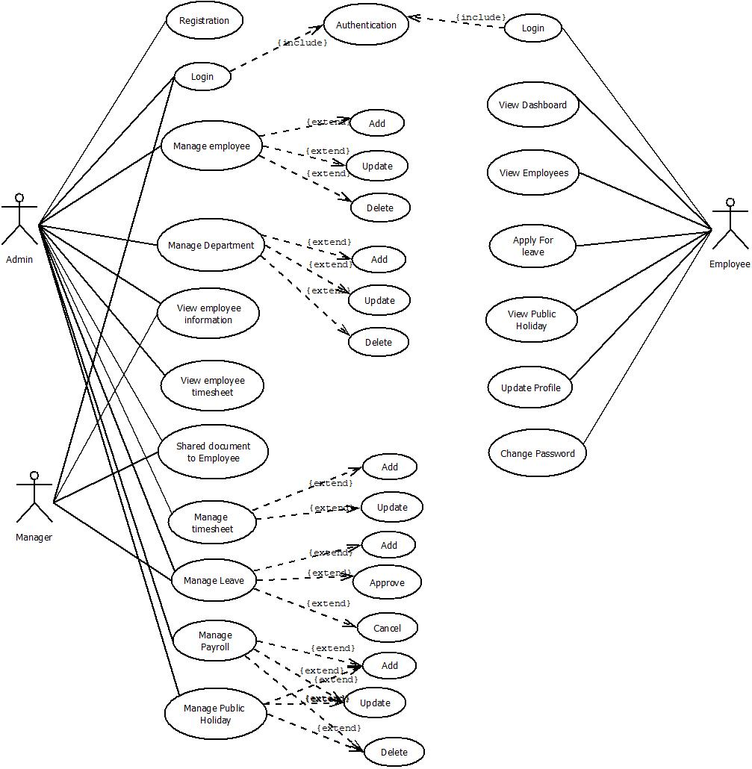

**Class**

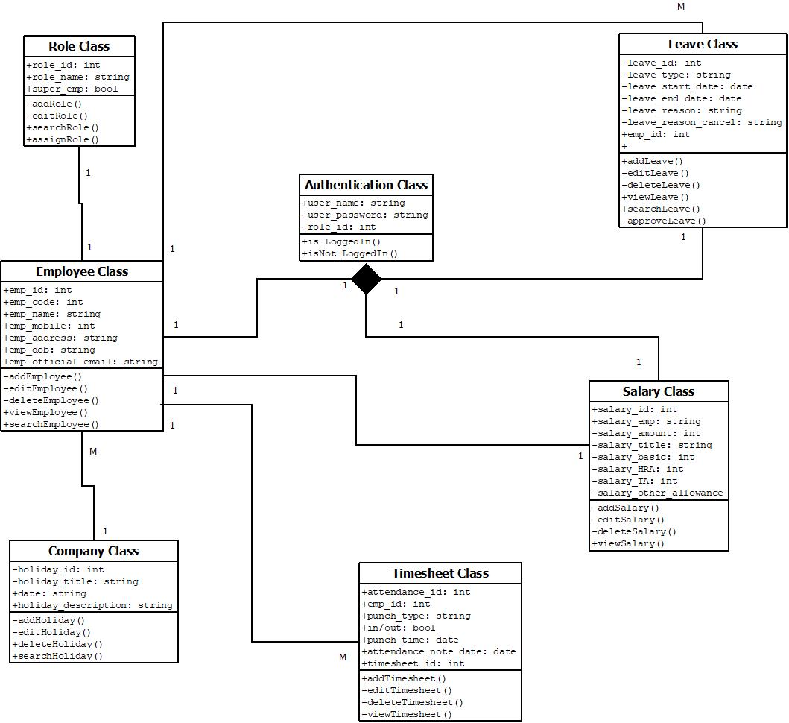

**Activity**

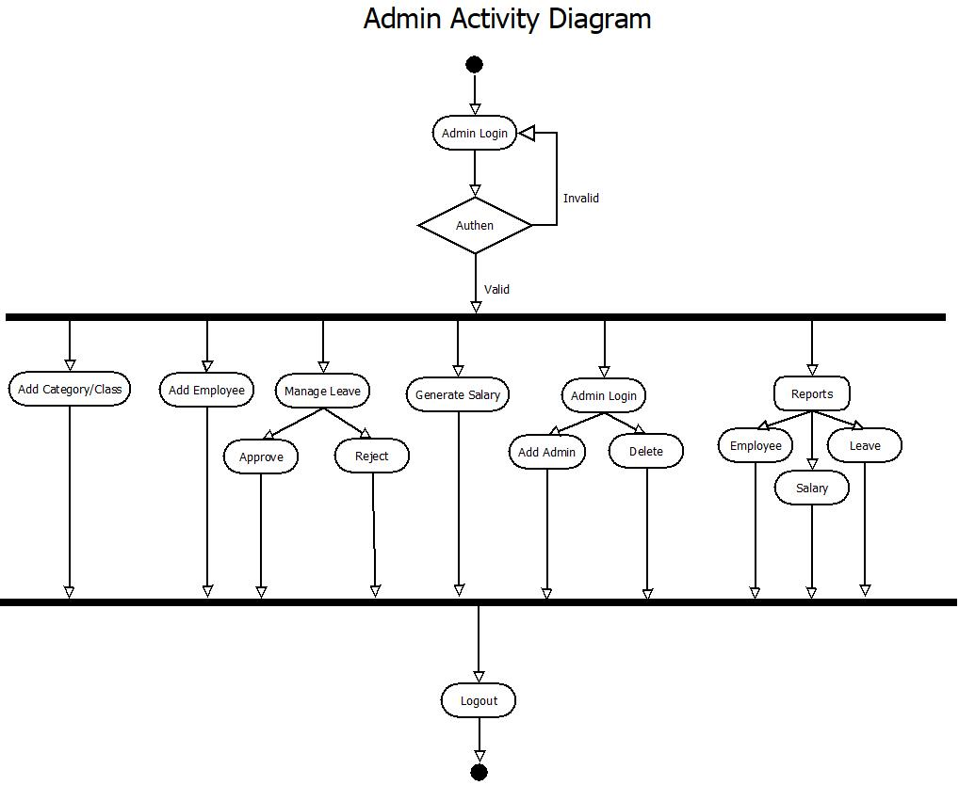

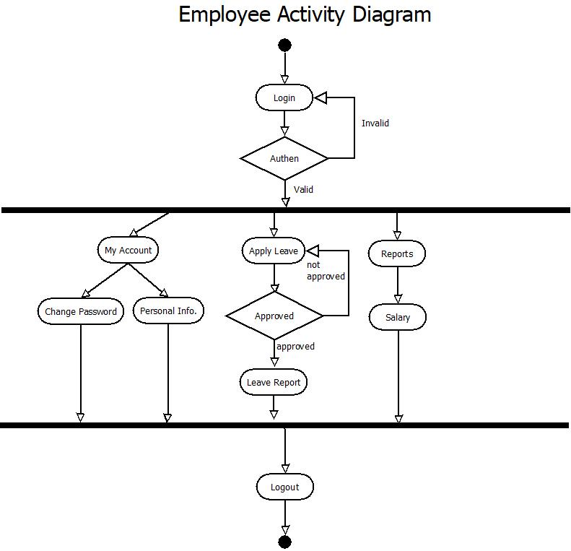

**Sequence**

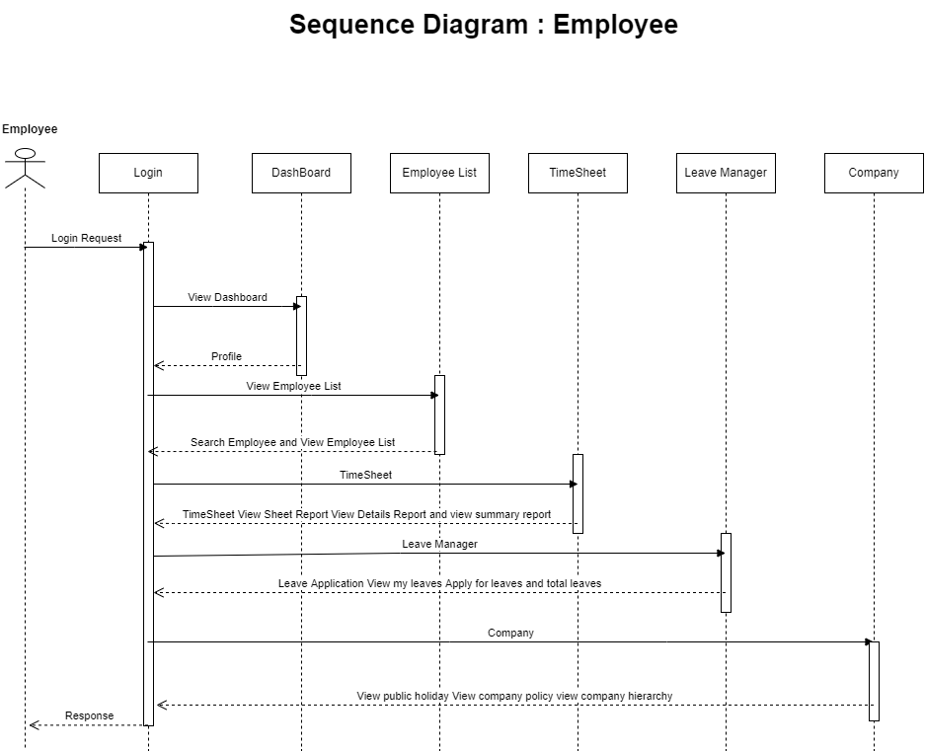

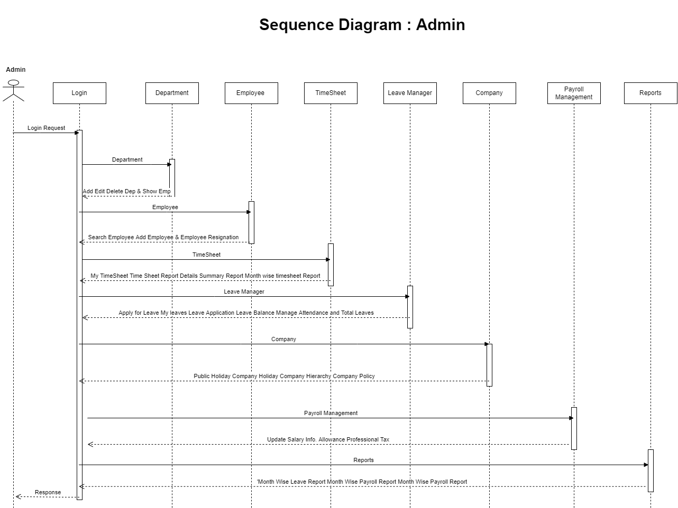

**ER**

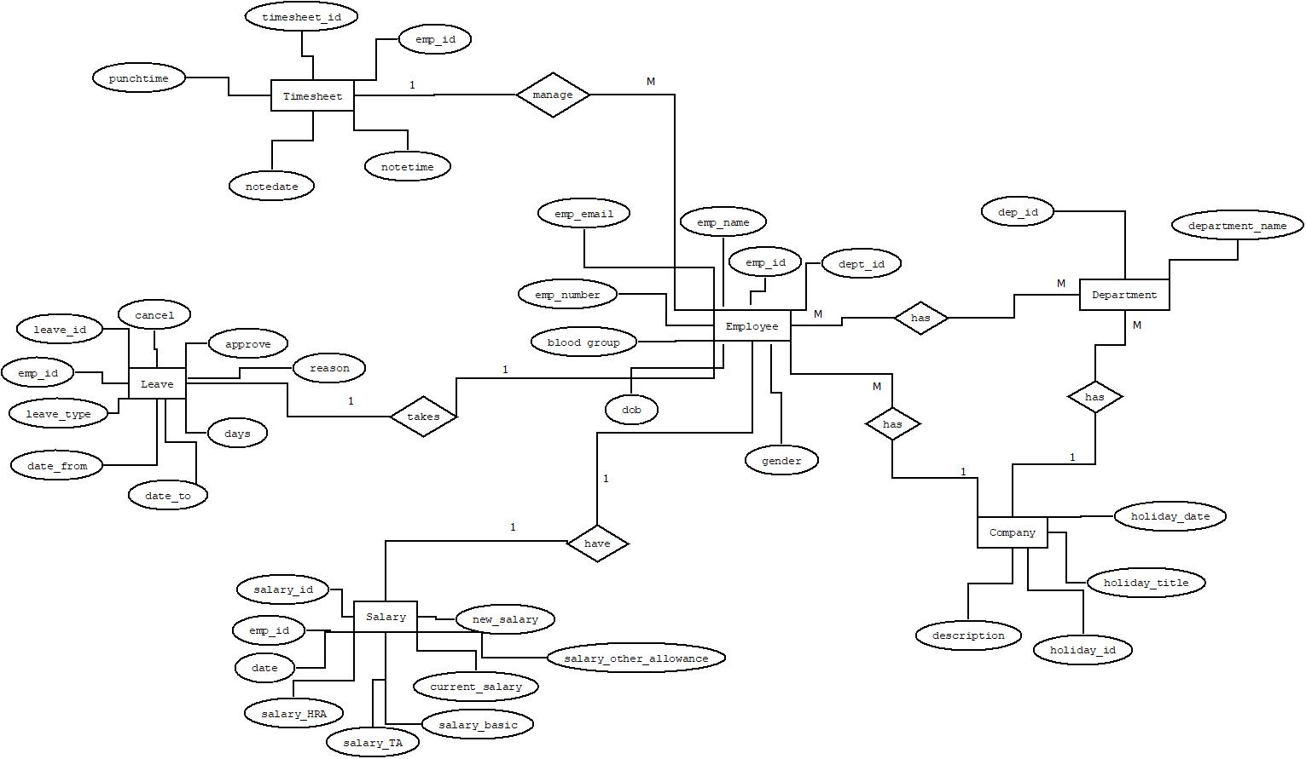

**Implementation (Screen Short and Reports)**